**Lesson18 Apply Azure Container Registry**

**Notes: -**

**1-in order to apply custom image to applied on multiple VM’S without manually apply it manually , you can use Azure container registry to upload it online and with simple azure cli on each VMS you can inform each one that any change on the custom docker image that located inside Azure container registry will be**

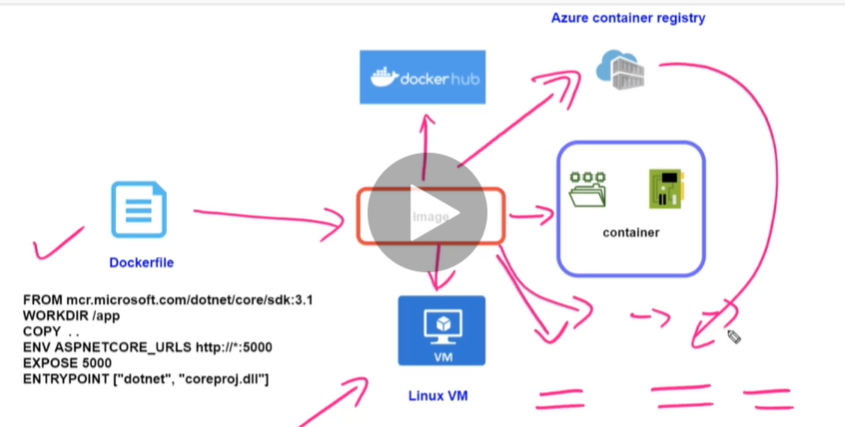

**(with Azure container registiry you can used to store custom docker images and any update on the custom docker images will be applied to all VMS that will download and applied automatically)**

**Steps:-**

**1-on azure > create container registry**

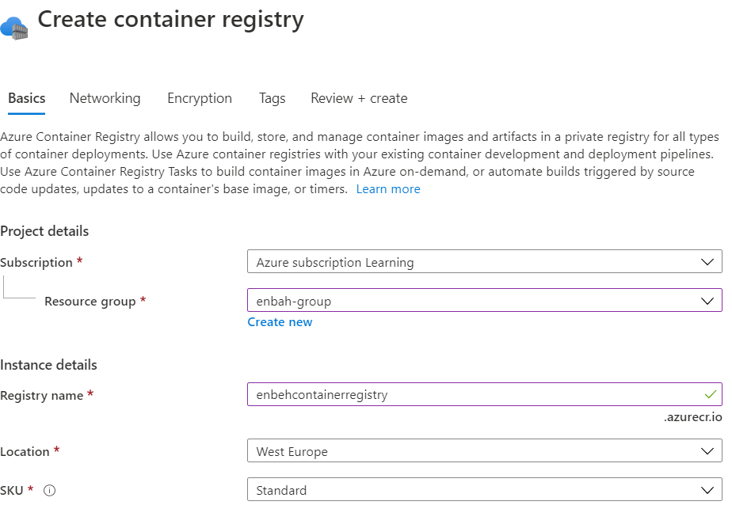

**2-we login to ubuntu VM and open Putty and apply the following commands**

**Install the Azure command line interface and authenticate into the ubuntu VM**

**curl -sL https://packages.microsoft.com/keys/microsoft.asc | \**

**gpg --dearmor | \**

**sudo tee /etc/apt/trusted.gpg.d/microsoft.asc.gpg > /dev/null**

**AZ_REPO=$(lsb_release -cs)**

**echo "deb [arch=amd64] https://packages.microsoft.com/repos/azure-cli/ $AZ_REPO main" | \**

**sudo tee /etc/apt/sources.list.d/azure-cli.list**

**sudo apt-get update**

**sudo apt-get install azure-cli //it will install azure cli on ubountu VM**

**sudo az login //it will apply login**

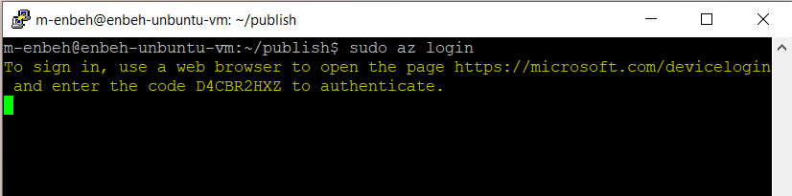

(you enter the D4CBR2HXZ as code on the below url to authenticate Azure CLI to apply upload custom image from ubuntu vm to azure VM and other things)

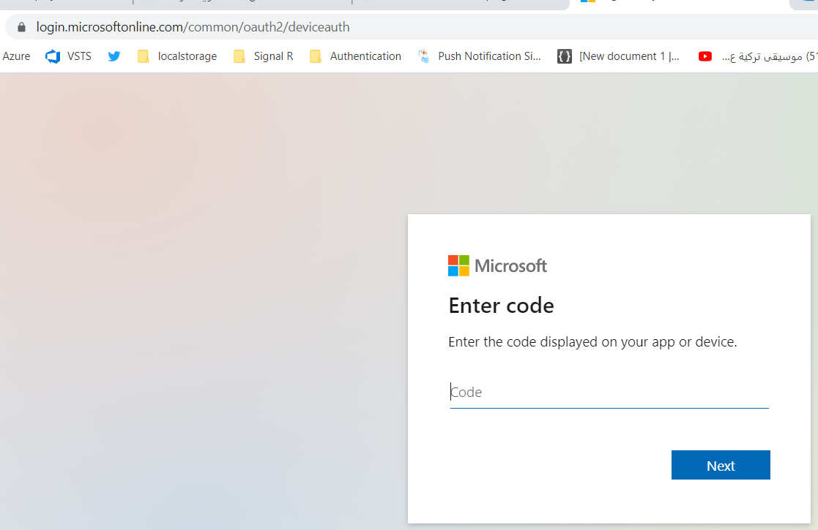

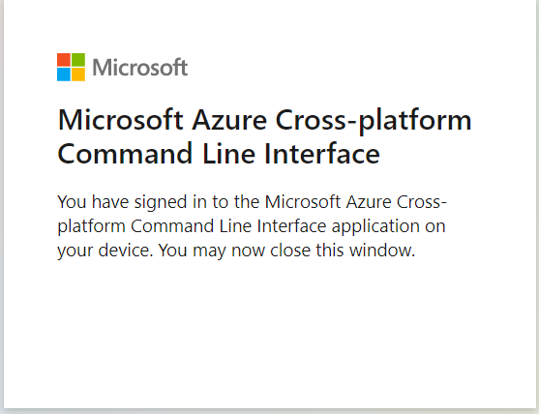

**//this section is to login to registry container and apply upload custom docker image to it**

**sudo az acr login --name enbehcontainerregistry //login to container registry**

**//it will make login by pass server url with username and password**

**sudo docker login enbehcontainerregistry.azurecr.io -u enbehcontainerregistry -p ED92qhbcQ85XteN+P+9uGfDP/unphfRK**

**sudo docker tag dotnetapp enbehcontainerregistry.azurecr.io/dotnetapp**

**(it will inform the container registry that prepare to create custom docker image)**

**sudo docker push enbehcontainerregistry.azurecr.io/dotnetapp**

**(upload custom docker image into the container registry)**

**(you will see that we apply upload custom docker image from ubuntu VM to azure contianer registry)**

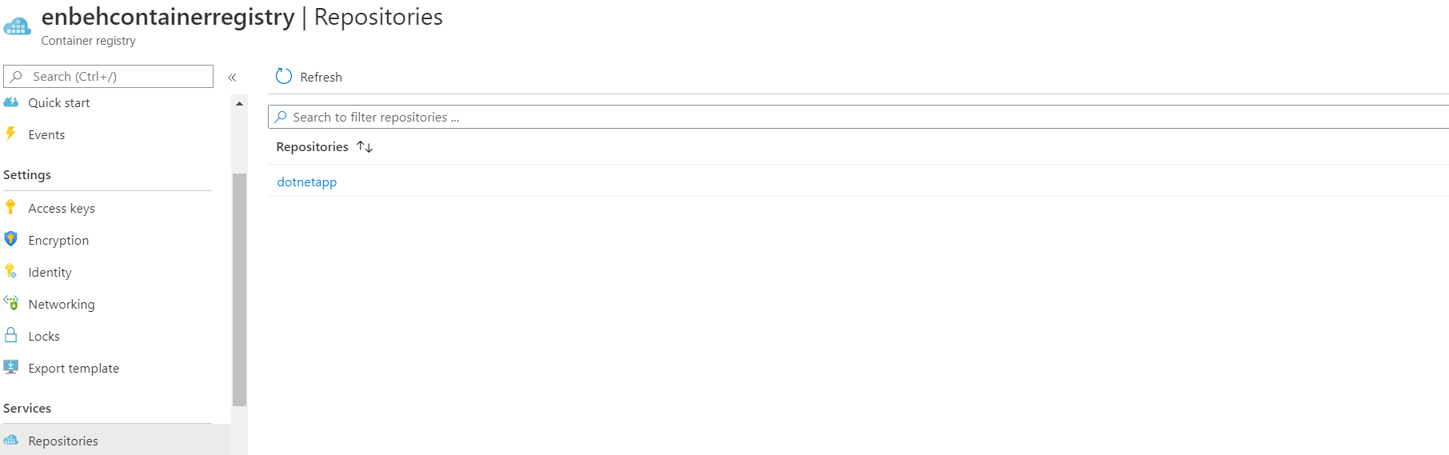

**Azure Container Instances**

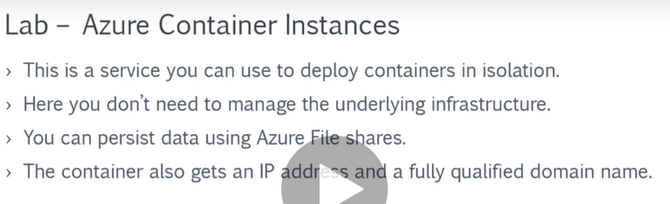

**The advantages of using Azure Container Instances**

**1-you don’t have to create VM**

**2-you don’t have to install docker runtime**

**3-each container instance has its own IP address and port no accessable and custom image deployed**

Steps:-

1-on azure portal > container register > click on update and enable admin user

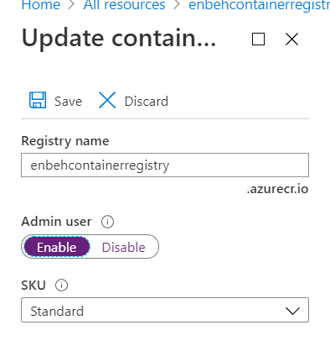

**1-on azure portal > search > container registery > repositories > create container instance (we set port == 5000 and Location == west europe)**

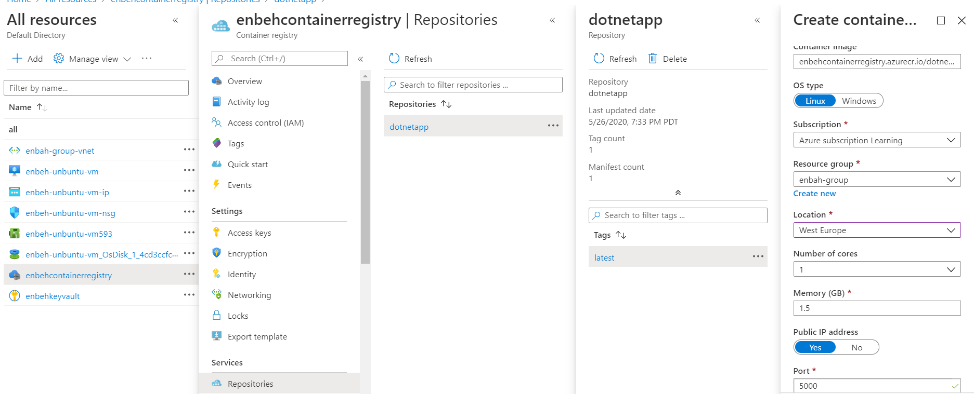

**2-on the browser type the following URL**

[**http://51.138.46.104:5000/**](http://51.138.46.104:5000/)